* **Install VirtualBox (VM ware)**

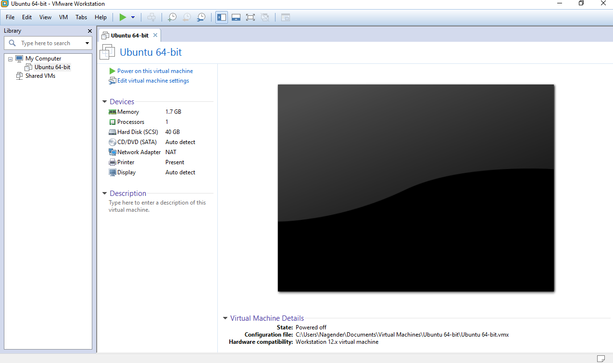

* **Install CentOS 7 (Ubuntu)**

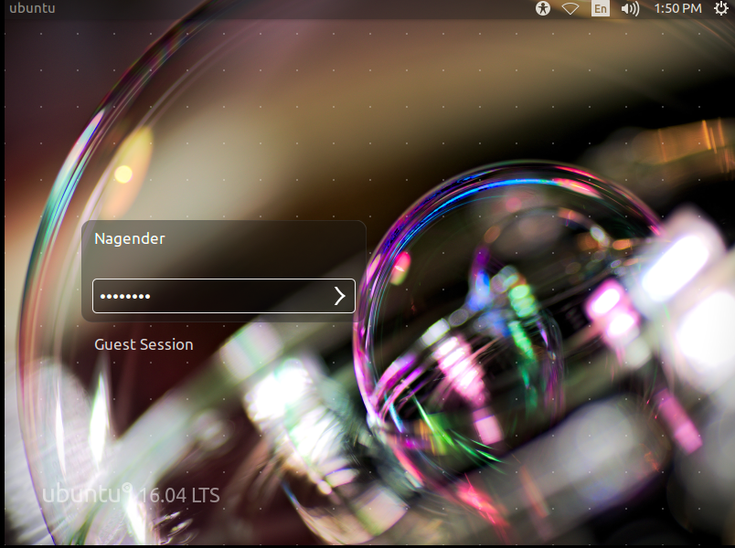

* **Create a user as your first letter in the first name and last name.**

**Ex: Kranthi kavuri = kkavuri**

* **Go to your home directory.**
* **Create subdirectories in your home directory with your username + 1 & 2.**

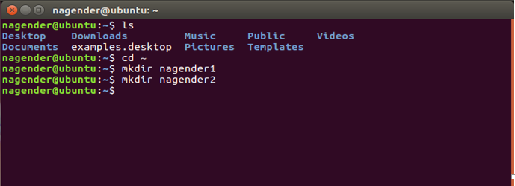

* **Create a file with your username.**

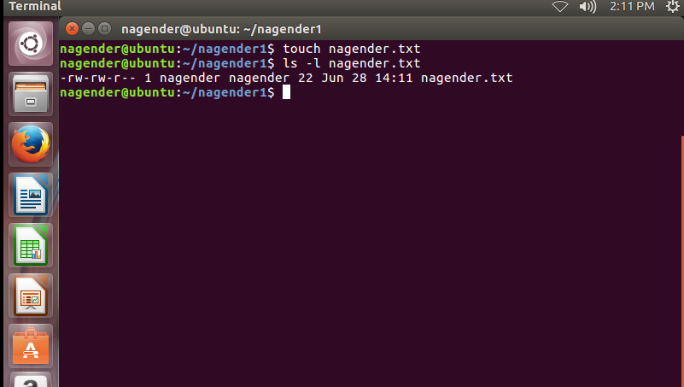

* **Change the permissions for the file to read and write but not execute.**

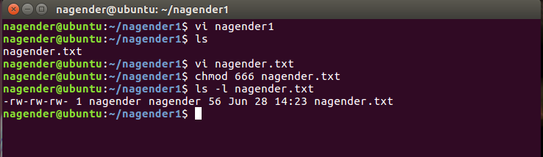

* **Change the permission for the file to read and execute but not write.**

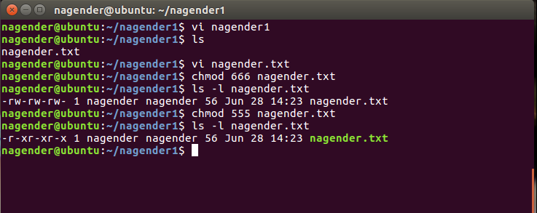

**Write two lines in a file and display it to the screen.**

